**AWS Creating Admin User Account**

The AWS Management Console requires your username and password so that the service can determine whether you have permission to access its resources. However, we recommend that you avoid accessing AWS using the credentials for your root AWS account; instead, we recommend that you use AWS Identity and Access Management (IAM) to create an IAM user and add the IAM user to an IAM group with administrative permissions. This grants the IAM user administrative permissions. You then access the AWS Management Console using the credentials for the IAM user. In this lab, you will create one using the IAM console.

To create an administrator user for yourself and add the user to an Administrators group (console) :

1. Sign in to the AWS console (<https://aws.amazon.com/console/>) as the account owner by choosing **Root** user and entering your AWS account email address. On the next page, enter your password.

2. Under *All Services: Security, Identity, & Compliance* (or type in the Search box **IAM**) choose IAM, Users and then choose Add user.

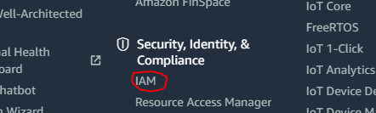

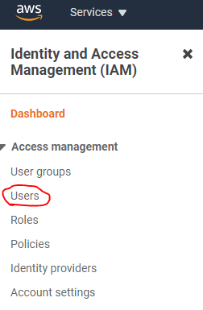

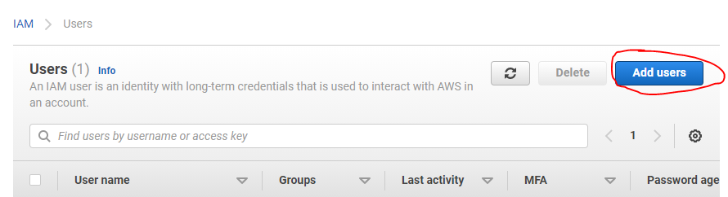

3. For User name, enter **Administrator**. Click **Next** button   
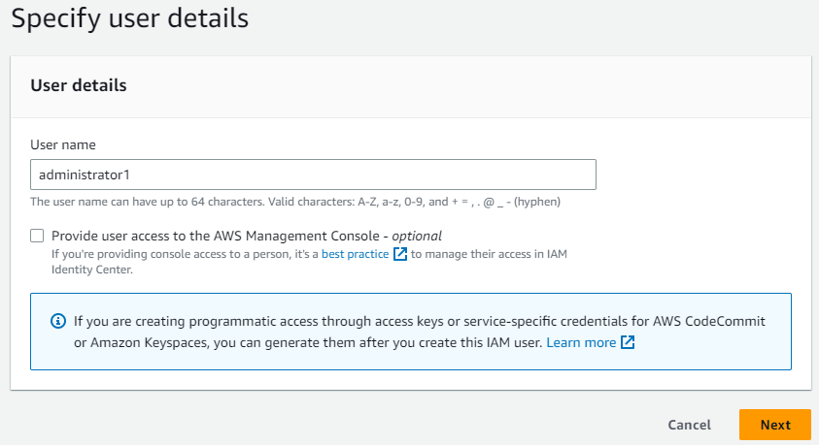

4. Under *Set permissions*, choose **Add user to group**.

5. Click **Create group** button under *User groups*

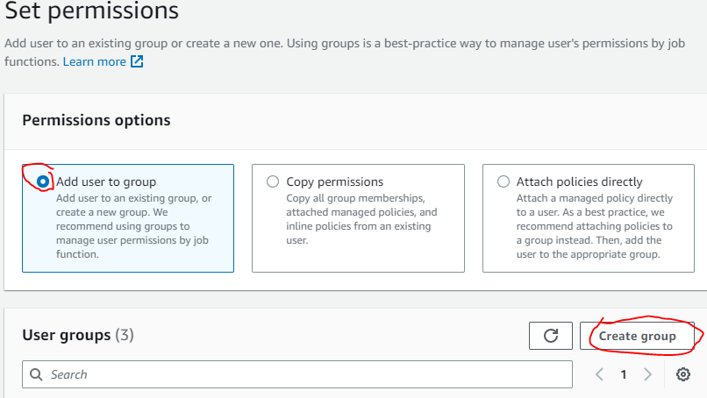

6. In the Create group dialog box, for Group name enter **Administrators**.

7. In the Permissions policies list, select the check box for ***AdministratorAccess***. Then choose **Create group**. (Note You must activate IAM user and role access to Billing before you can use the AdministratorAccess permissions to access the AWS Billing and Cost Management console. To do this, follow the instructions in ***Enabling Access to IAM Billing*** below.)

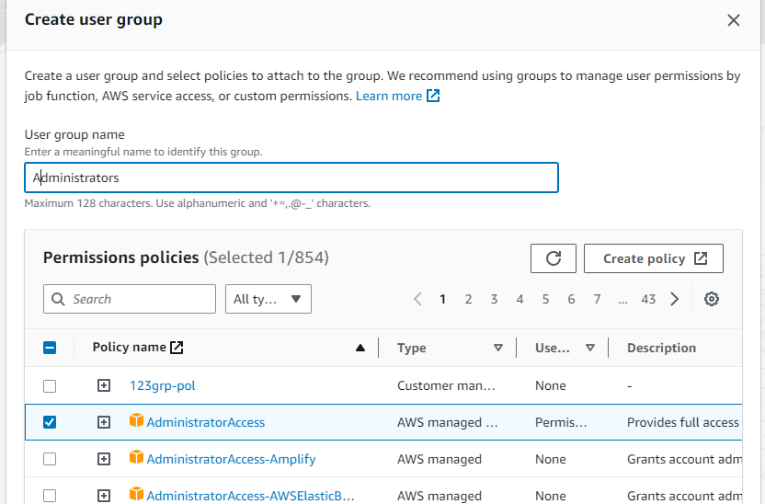

8. Back in the list of groups, select the check box for your new group. Choose Refresh if necessary to see the group in the list.

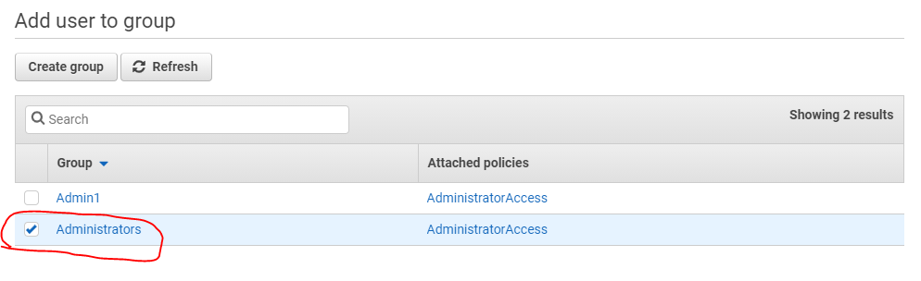

9. Choose **Next**

10. Add metadata to the user by attaching tags as key-value pairs under Tags by clicking **Add new tag**. For *Key* type **Name** and for *Value*, type **Administrator.**

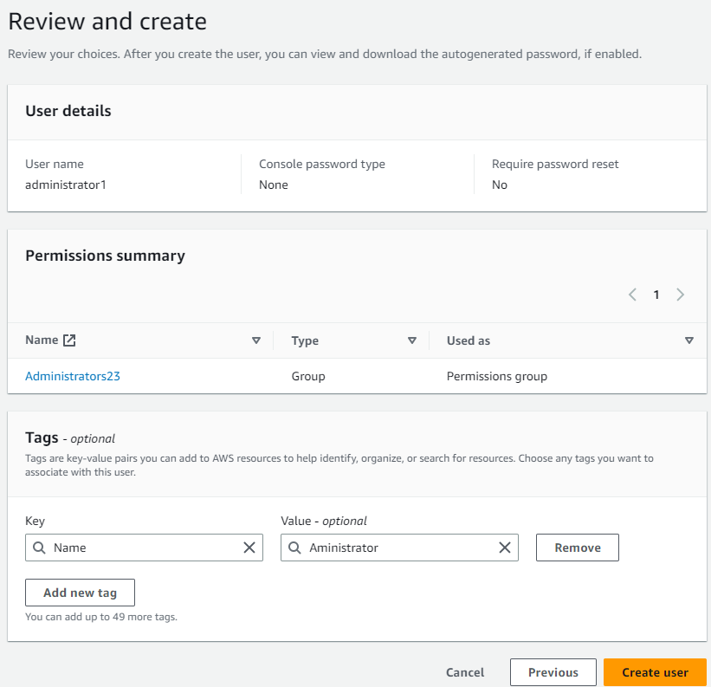

11. Click **Create user**.

12. You should see the new user in the User list

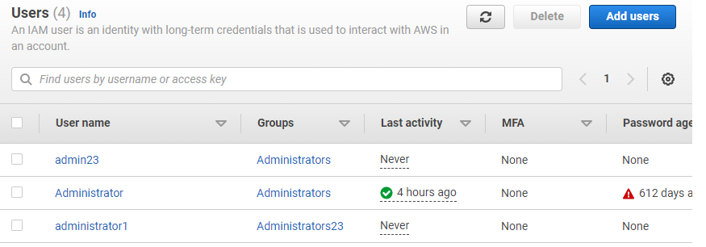

You can use this same process to create more groups and users and to give your users access to your AWS account resources.

13. Click on the new user. Notice under *Summary*, this user doesn’t have Console access

14. Click the *Security credentials* tab, then the **Enable console access** button.

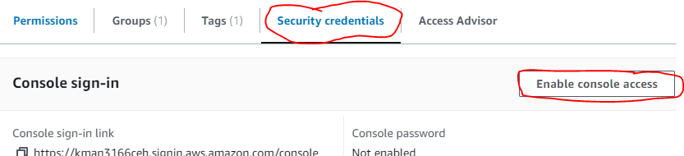

15. In the Manage console access pop-up, select **Enable** under *Console access*. Select Custom password and type in a password for this user.

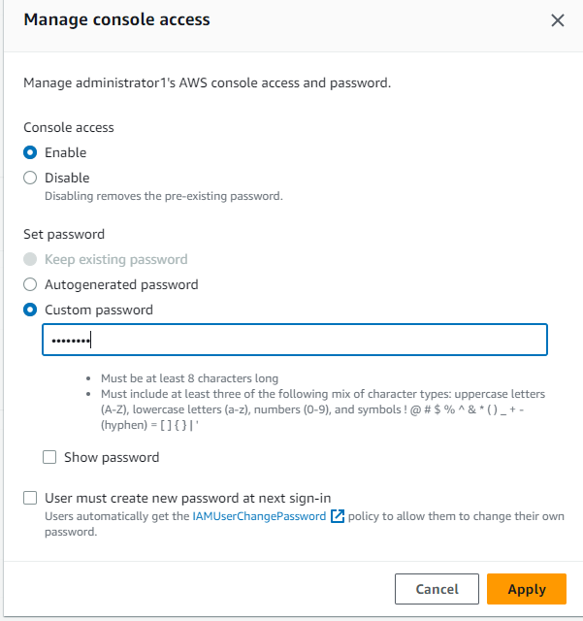

16. Click the **Apply** button. **Download** the .csv file as save it to your local drive.

17. Click **Close**.

18. To sign in as this new IAM user **Administrator**, open a private browser tab (In Chrome this is called Incognito window), then your URL to login

A) Create an account alias name (from the **Root** login window) by going to the IAM dashboard and on the far right of the page (under AWS Account), click Customize and enter an alias as **yourlastname-aws (**if you already have an alias, don’t change; if you have a common last name, just add numbers to your last name as your alias must be unique across AWS**)**.

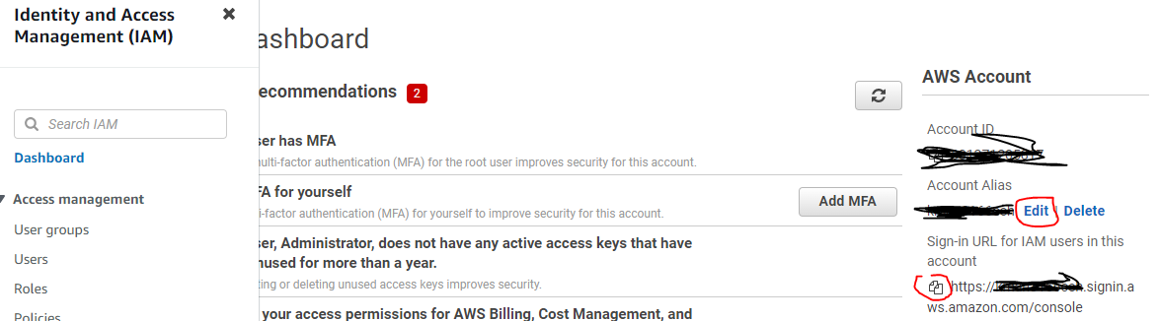

B)To sign in after you create an account alias, open a new tab and use the following URL:  
<https://your_account_alias.signin.aws.amazon.com/console/>

Or

Click the copy icon next to your alias URL under AWS Account in your Root tab and paste into a Private tab. If you don’t use a private or Incognito window, if may just take you to your Root login again.  
  
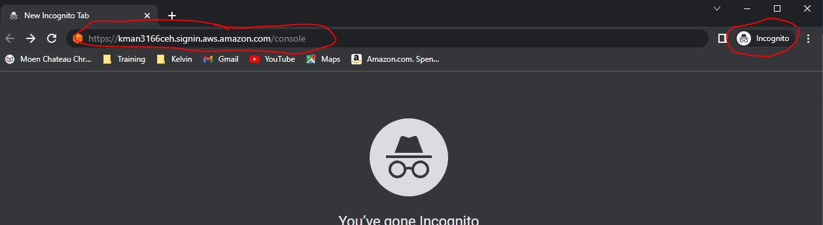

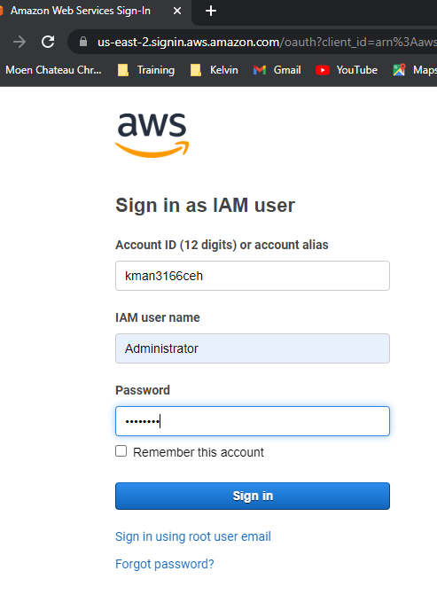

19. Once logged in, **open a Word doc (or pdf) and paste your screenshot your new account login showing the “username@alias” and upload to Bb**:



20. Logout of both the administrator and root accounts.